Press Release

ETHNA System comes to a close

Castelló de la Plana, Spain, 30.06.2023 – After 42 months, the European Commission funded initiative ETHNA System successfully concludes. The project leaves behind a wealth of resources that will provide higher education, innovation ecosystems, funding and research centres with a robust basis for implementing a flexible ethical governance system.
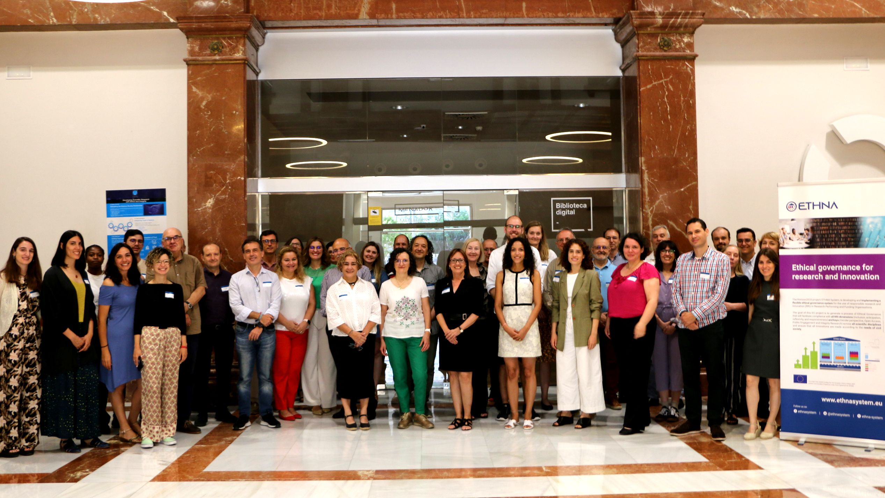
To evaluate the project results and share experiences, ETHNA System consortium members and extended stakeholders linked to research and innovation domains met on the 15th and 16th June in Castelló de la Plana, Spain. Under the theme of “Ethics and Responsible Research and Innovation in Practice”, the Final Conference spurred discussions on the significance of the outputs of the ETHNA System project to inform future initiatives and the most pressing ongoing developments in the field of Responsible Research and Innovation (RRI).

Looking back, the ETHNA System project leaves behind many outputs and practical guides for the development of an ethical governance system in Research Performing and Funding Organisations (RPOs and RFOs), most notably the Guide with the accompanying toolbox. In addition to these final project outcomes, three handbooks on stakeholder engagement provide guidance on how to map stakeholders and scope their involvement, monitor and respond to their needs and engage them in participatory events. A blueprint for institutional change gives practical recommendations on how to bring an effective RRI governance to life and foster sustainable institutional change by identifying the right incentives and tackling the most crucial barriers with appropriate measures.

At the heart of the project, the piloting of the ETHNA System in living labs in six different organisations from Spain (UJI and Espaitec), Norway (NTNU), Estonia (Harno), Portugal (Uninova) and Bulgaria (ARC Fund) provided a wide range of information to draw conclusions from. Many of these key insights have been summarised in the implementation document “5 years ETHNA System Sustainability Plan” and its accompanying manual of trainers on the ETHNA System.
Among the project’s results, the Open Access book "Ethics and Responsible Research and Innovation in Practice” stands out as the culmination of over three years of dedicated project work. The book is part of the series Lecture Notes in Computer Science and was edited by Elsa González-Esteban and Ramón A. Feenstra from the Universitat Jaume I (UJI) of Castelló, and Luis M. Camarinha-Matos at NOVA University of Lisbon and UNINOVA.
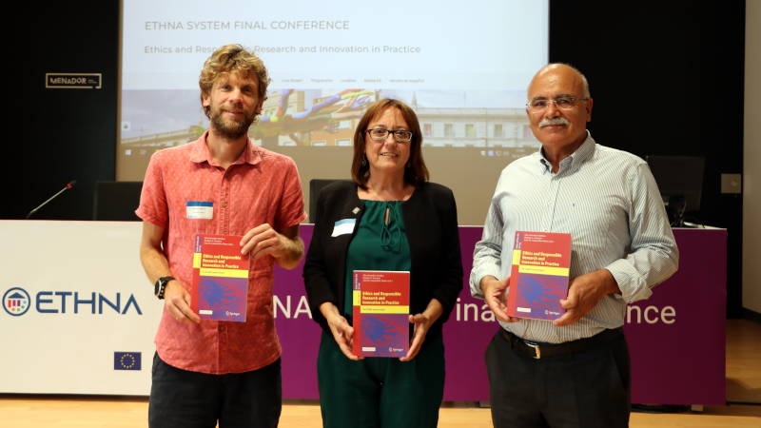
The book skilfully brings together a range of practical results developed by the ETHNA System consortium over the course of the project and includes relevant contributions from prominent researchers in the field of RRI. Its main objective is to provide a practical and useful guide that will help other institutions to start introducing governance on research ethics effectively in their organisations. It succinctly presents practical contributions to the ethics governance framework, the conceptualisation and characteristics of ethics tools, as well as the experience gained from their application in different institutions. Contributions from beyond the ETHNA System consortium round out experiences across Europe with ethics tools in practice.
Lastly, the project presents a policy brief with recommendations for relevant policy makers on how to promote ethical and effective self-regulation with and for society. “We believe that the ETHNA System allows for the continuous openness to the values and social and ethical expectations of its stakeholders through its ethics governance system,” notes Elsa González-Esteban, professor at UJI and director of the project. “I am proud of the hard work of the consortium and the legacy it leaves behind in RRI implementation.”

